Sand chart vs. streamgraph

# Recommendation:

Use sand chart, since categories don’t change over time or start and stop at different times. Sand or area chart is basically showing stacked bar chart over time

Also, I think it’s hard to visually tell the difference between a square area of 5x5 vs. a rectangular area of 1x25.

# STREAM

<http://seeingdata.org/taketime/inside-the-chart-stream-graph/>

Def: They are often used to show changes of different categories over time when there are many categories AND these categories start and stop at different times.

EX: Stream graphs might be used to show how much money films have made when those films have not been released at exactly the same time. This would tell us something about the seasonality of cinema going.

Perhaps the best known example of a streamgraph was published in the New York Times in February 2008 depicting the ['Ebb and Flow of Movies: Box Office Receipts Over Past 20 Years'.](http://www.nytimes.com/interactive/2008/02/23/movies/20080223_REVENUE_GRAPHIC.html)

Beware: The vertical dimension of a stream graph does not mean positive or negative; it is purely concerned with the best stacking arrangement. Don’t try to read the values of the height of a slice at a given point, focus instead on the bigger picture.

EX: Ebb and Flow from NYT (2008)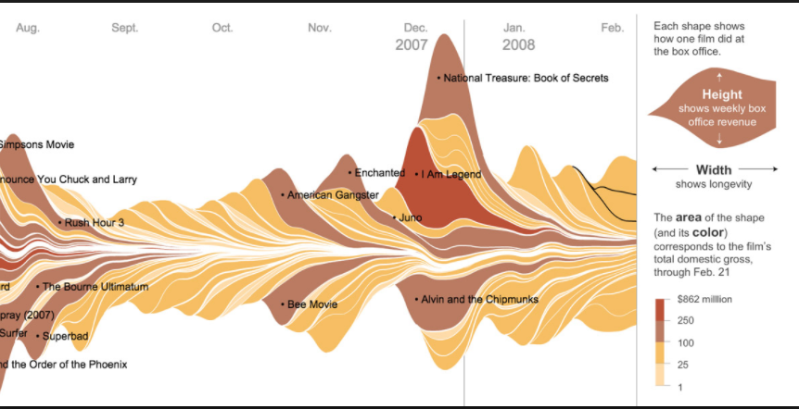

# Sand chart

**Use** a stacked area **chart** to display the contribution of each value to a total over time. To create an area **chart**, execute the following steps. 2. On the Insert tab, in the**Charts** group, click the Line symbol.

### [**Area Chart in Excel - EASY Excel Tutorial**](http://www.excel-easy.com/examples/area-chart.html)

www.excel-easy.com/examples/area-chart.html

**Use** a stacked **area chart** for multiple data series with part-to-whole relationships or for cumulative series of values. There are three main variations on this **chart**, and each has its best **use**, depending on the situation. Standard **Area Chart**: This is best used to show or compare a quantitative progression over time.